Bug Report – TutorialsNinja

Bug# | Description | Severity
TW1-I1 | 'Thank you for registering' email is not received to the registered email address after registering an account | Minor
TW1-I2 | User is able to register an account by providing an invalid phone number | Minor
TW1-I3 | 'Privacy Policy' Checkbox field in 'Register Account' page is not marked with red colour * symbol | Minor
TW1-I4 | 'Telephone' field in 'Register Account' page is accepting the spaces and not showing warning message | Minor
TW1-I5 | 'Password' and 'Password Confirm' fields in 'Register Account' page are accepting simple passwords | Major
TW1-I6 | Leading and Trailing spaces are accepted by the text fields in the 'Register Account' page | Minor
TW1-I7 | User is getting logged out on clicking Browser back button | Critical
TW1-I8 | User is getting logged in automatically on browsing back immediately after logout | Major
TW1-I9 | Password is visible in the Page Source code of the Password field of 'Login' page | Major
TW1-I10 | User is not automatically getting logged out of the Application after 30 minutes of inactivity | Major
TW1-I11 | User is not getting logged out in one browser, when logged out in another browser | Minor
TW1-I12 | Email address is not getting carry forwarded from the 'Login' page to 'Forgot Your Password' page | Minor
TW1-I13 | Using tab keyboard key is not highlighting the 'Search in subcategories' checkbox field | Minor
TW1-I14 | Negative, Null and Zero values are accepted by the Qty field in Product Display Pages | Minor
TW1-I15 | Warning message informing the User to provide positive quantity is not getting displayed on updating the quantity with negative, zero or blank in the 'Shopping Cart' page | Minor
TW1-I16 | $8 is displayed instead of $5 in the displayed 'Estimate Shipping & Taxes' dialog | Major
TW1-I17 | User can provide future date for the 'Order Date' field while returning the order | Major
TW1-I18 | Page text is not displayed in the 'About Us', 'Delivery Information', 'Privacy Policy' and 'Terms & Conditions' page | Minor
TW1-I19 | Normal User who has not registered for the Affiliate account is able to login from 'Affiliate Login' section | Major
TW1-I20 | Options are not displayed in the 'Select' dropdown list of 'Canon EOS 5D' product display page | Major
TW1-I21 | Logo of the Application is missing, instead 'Your Text' is getting displayed | Minor
TW1-I22 | Clicking on the first Hero image is taking us to a wrong Product Display Page | Minor
TW1-I23 | A blank 'Contact Us' page is displayed on submitting the form in 'Contact Us' page | Minor

Bug Id | TW1-I1

Brief Summary | 'Thank you for registering' email is not received to the registered email address after registering an account

Severity | Minor

Steps to Reproduce

1. Open the Application URL
2. Click on 'My Account' dropmenu
3. Select 'Register' option
4. Enter the new User valid details into the 'Register Account' page
5. Select the 'Privacy Policy' checkbox option
6. Click on 'Continue' button

Expected Result:

User Account should be created and an email with the subject 'Thank you for registering' should be received by the registered email address.

Actual Result:

User Account is getting created, but the email with subject 'Thank you for registering' is not received to the registered email address.

Screenshot

Not Applicable
Top
Bug Id | TW1-I2

Brief Summary | User is able to register an account by providing an invalid phone number

Severity | Minor

Steps to Reproduce

1. Open the Application URL
2. Click on 'My Account' dropmenu
3. Select 'Register' option
4. Enter valid details into the fields displayed on the 'Register Account' page
5. Enter invalid phone number say abcde into the 'Telephone' field
6. Select 'Privacy Policy' checkbox field
7. Click on 'Continue' button

Expected Result:

Warning message should be displayed informing the Users about the invalid phone number

Actual Result:

Warning message is not getting displayed, instead User account is getting created with invalid phone number

Screenshot

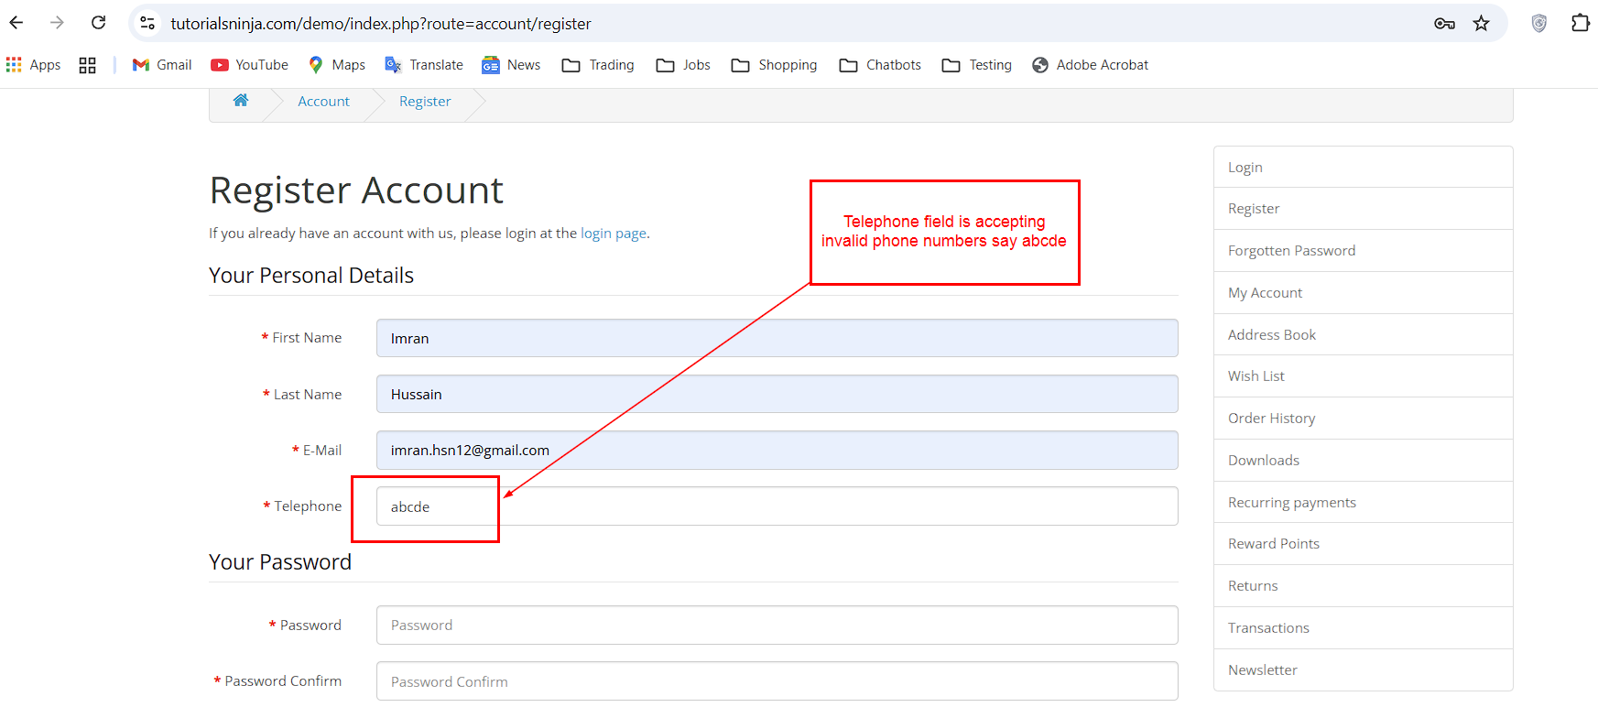
Top
Bug Id | TW1-I3

Brief Summary | 'Privacy Policy' Checkbox field in 'Register Account' page is not marked with red colour * symbol

Severity | Minor

Steps to Reproduce

1. Open the Application URL in any browser
2. Click on 'My Account' Dropmenu
3. Select 'Register' option
4. Check the 'Privacy Policy' checkbox field in the displayed 'Register Account' page

Expected Result:

'Privacy Policy' check box field should be marked with red colour * symbol
Actual Result:

'Privacy Policy' check box field is mandatory but not marked with red colour * symbol.

Screenshot

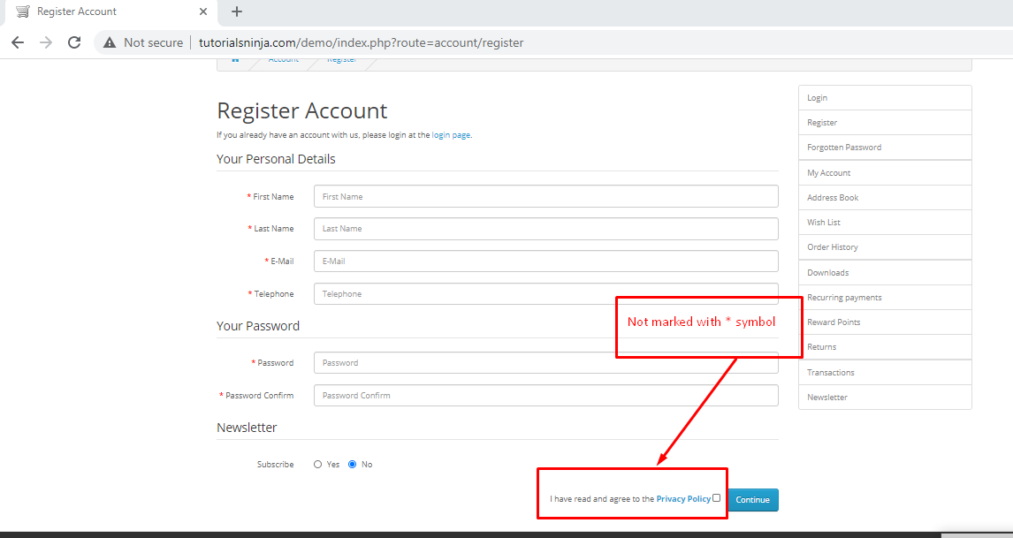
Top

Bug Id | TW1-I4

Brief Summary | 'Telephone' field in 'Register Account' page is accepting the spaces and not showing warning message

Severity | Minor

Steps to Reproduce

- Open the Application URL in any browser
- Click on 'My Account' dropmenu
- Selection 'Register' option
- Enter spaces into all the mandatory fields including 'Telephone' field
- Select the 'Privacy Policy' checkbox field
- Click on 'Continue' button
Expected Result:

Warning message informing the User to enter the Telephone field should be displayed

Actual Result:

Telephone field is accepting the spaces and no field level warning message is displayed for this field.

Screenshot
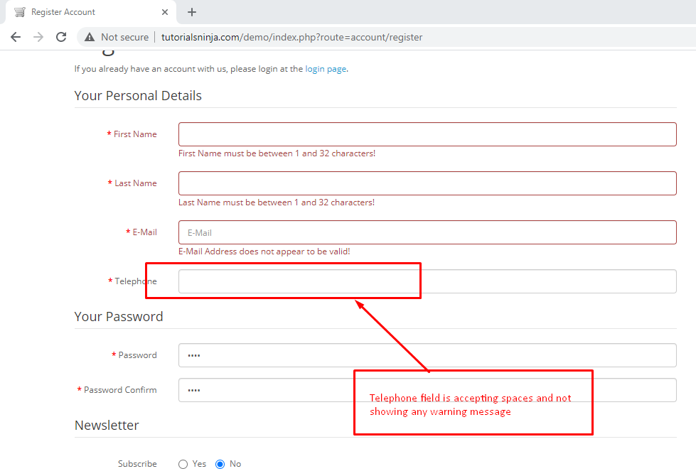

Top
Bug Id | TW1-I5

Brief Summary | 'Password' and 'Password Confirm' fields in 'Register Account' page are accepting simple passwords

Severity | Major

Steps to Reproduce

- Open the Application URL in any browser
- Click on 'My Account' dropmenu
- Select 'Register' option
- Enter details into all the mandatory fields
- Enter simple password say 'abcd' into the 'Password' and 'Password Confirm' fields
- Select 'Privacy Policy' checkbox field
- Click on 'Continue' button

Expected Result:

Warning message informing the User to enter a password matching the complexity standards should be displayed

Actual Result:

Simple password got accepted and there is no warning message regarding the complexity standards of the Password.

Screenshot

Not Applicable
Top

Bug Id | TW1-I6

Brief Summary | Leading and Trailing spaces are accepted by the text fields in the 'Register Account' page

Severity | Minor

Steps to Reproduce

- Open the Application URL in any browser
- Click on 'My Account' dropmenu
- Select 'Register' option
- Enter leading and trailing spaces to the text fields in the 'Register Account' page
- Select 'Privacy Policy' checkbox field
- Click on 'Continue' button
Expected Result:

Leading and Trailing spaces should not be accepted by the text fields in the 'Register Account' page

Actual Result:

Leading and Trailing spaces are accepted by the text fields in the 'Register Account' page and account is getting created.

Screenshot

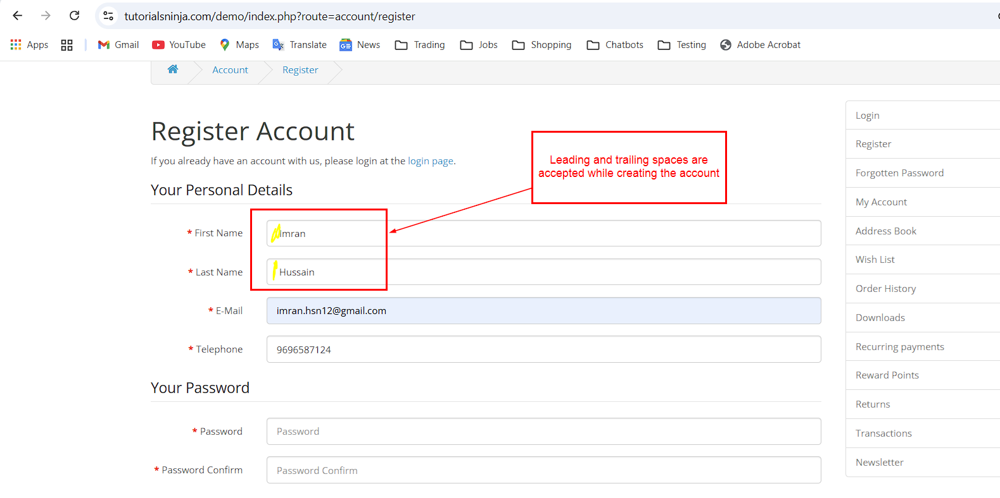
Top
Bug Id | TW1-I7

Brief Summary | User is getting logged out on clicking Browser back button

Severity | Critical

Steps to Reproduce

- Open Application URL in any browser
- Click on 'My Account' dropmenu
- Select 'Login' option
- Enter valid email address into 'E-Mail Address' field and valid password into 'Password' field
- Click on 'Login' button
- Click on browser back button two times
Expected Result

User should not get logged out

Actual Result

User is getting logged out

Screenshot

Not Applicable
Top

Bug Id | TW1-I8

Brief Summary | User is getting logged in automatically on browsing back immediately after logout

Severity | Major

Steps to Reproduce

- Login to the Application
- Click on 'My Account' dropmenu
- Select 'Logout' option
- Click on browser back button
Expected Result

User should not get logged in automatically

Actual Result

User is getting logged in automatically

Screenshot

Not Applicable
Top

Bug Id | TW1-I9

Brief Summary | Password is visible in the Page Source code of the Password field of 'Login' page

Severity | Major

Steps to Reproduce

- Open Application URL in any browser
- Click on 'My Account' dropmenu
- Select 'Login' option
- Enter password into the 'Password' field on the 'Login' page
- Click on 'Login' button
- Inspect the 'Password' text field

Expected Result:

Password should not be visible in the Page Source code

Actual Result:

Password is getting displayed in the Page Source code as shown in the attached screenshot

Screenshot

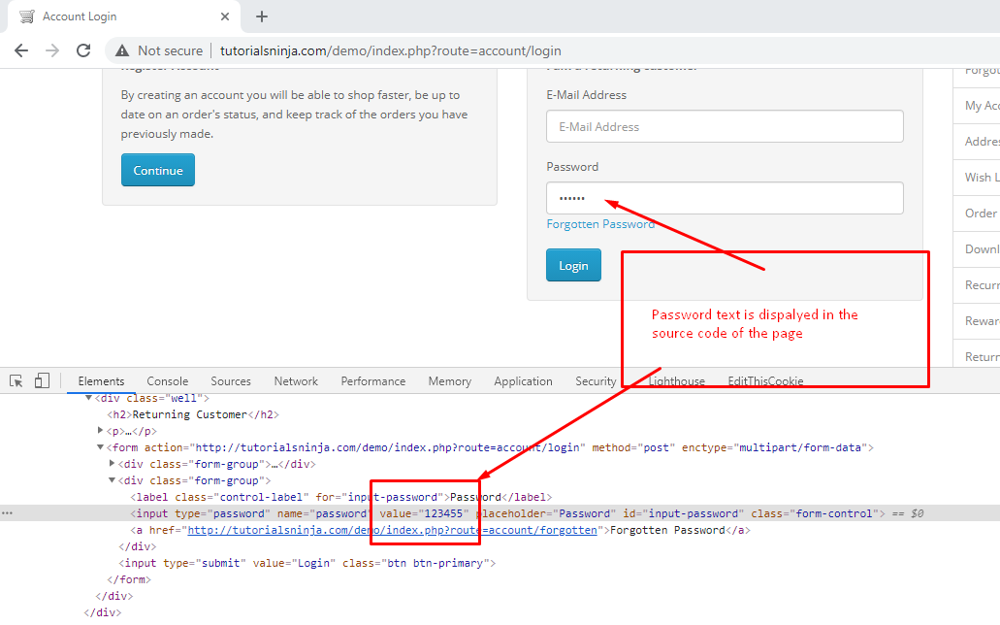
Top
Bug Id | TW1-I10

Brief Summary | User is not automatically getting logged out of the Application after 30 minutes of inactivity

Severity | Major

Steps to Reproduce

- Login to the Application with valid credentials
- Don't perform any action for next 30 minutes
- Try to perform any action after the above 30 minutes like Search a product etc.
Expected Result:

User should get automatically logged out

Actual Result:

User is not getting logged out

Screenshot

Not Applicable
Top

Bug Id | TW1-I11

Brief Summary | User is not getting logged out in one browser, when logged out in another browser

Severity | Minor

Steps to Reproduce

- Login to the Application with same credentials in Chrome and Firefox Browser
- Logout in Chrome browser
- Check performing any action in Firefox browser
Expected Result

User should also get logged out in Firefox browser

Actual Result

User is not getting logged out automatically in Firefox browser

Screenshot

Not Applicable
Top

Bug Id | TW1-I12

Brief Summary | Email address is not getting carry forwarded from the 'Login' page to 'Forgot Your Password' page

Severity | Minor

Steps to Reproduce

- Open Application URL
- Click on 'My Account' dropmenu
- Select 'Login' option
- Enter email address into the 'E-Mail Address' text field
- Click on 'Forgotten Password' link

Expected Result:

Email address given in Login page should get carry forwarded to 'Forgot Your Password' page

Actual Result:

Email address given in Login page is not getting carry forwarded to 'Forgot Your Password' page

Screenshot

Not Applicable
Top

Bug Id | TW1-I13

Brief Summary | Using tab keyboard key is not highlighting the 'Search in subcategories' checkbox field

Severity | Minor

Steps to Reproduce

- Open Application URL
- Click on 'Search' icon without entering any product name
- In the displayed 'Search' page, continuously press 'Tab' keyboard key
Expected Result:

All the options on the 'Search' page should get highlighted/focused.

Actual Result:

'Search in subcategories' checkbox field is not highlighted or focused.

Screenshot

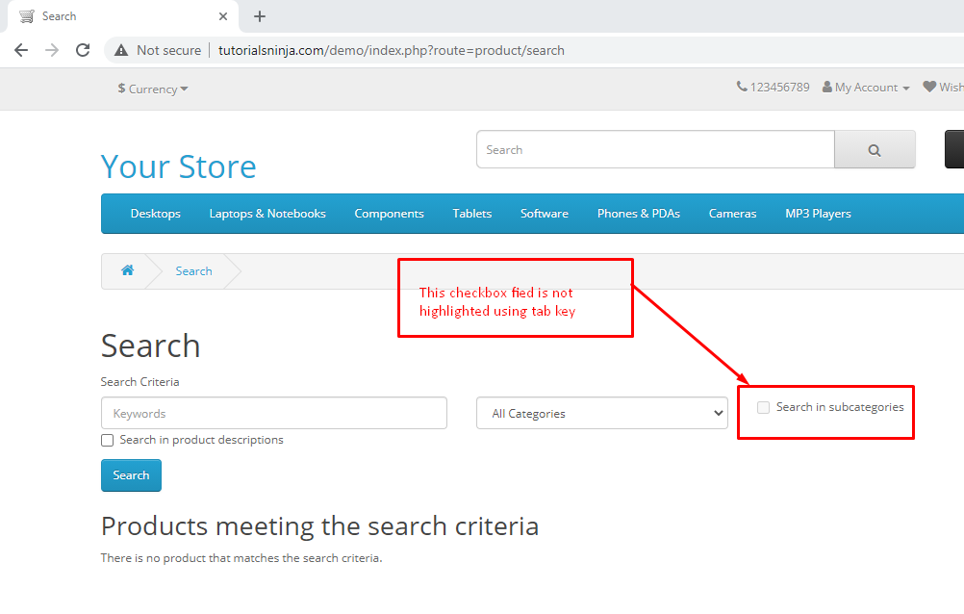
Top
Bug Id | TW1-I14

Brief Summary | Negative, Null and Zero values are accepted by the Qty field in Product Display Pages

Severity | Minor

Steps to Reproduce

- Open Application URL
- Enter any Product Name say 'iMac' into the Search box field
- Click on the button having Search icon
- Click the Product displayed in the Search results
- Change the quantity to Negative or Blank or Zero in the Qty field of Product Display Page
- Click on 'Add to Cart' button
Expected Result

Warning message informing the User to enter a positive quantity into the Qty field should be displayed

Actual Result

Success message with text - Success: You have added Product to your shopping cart! is getting displayed

Screenshot

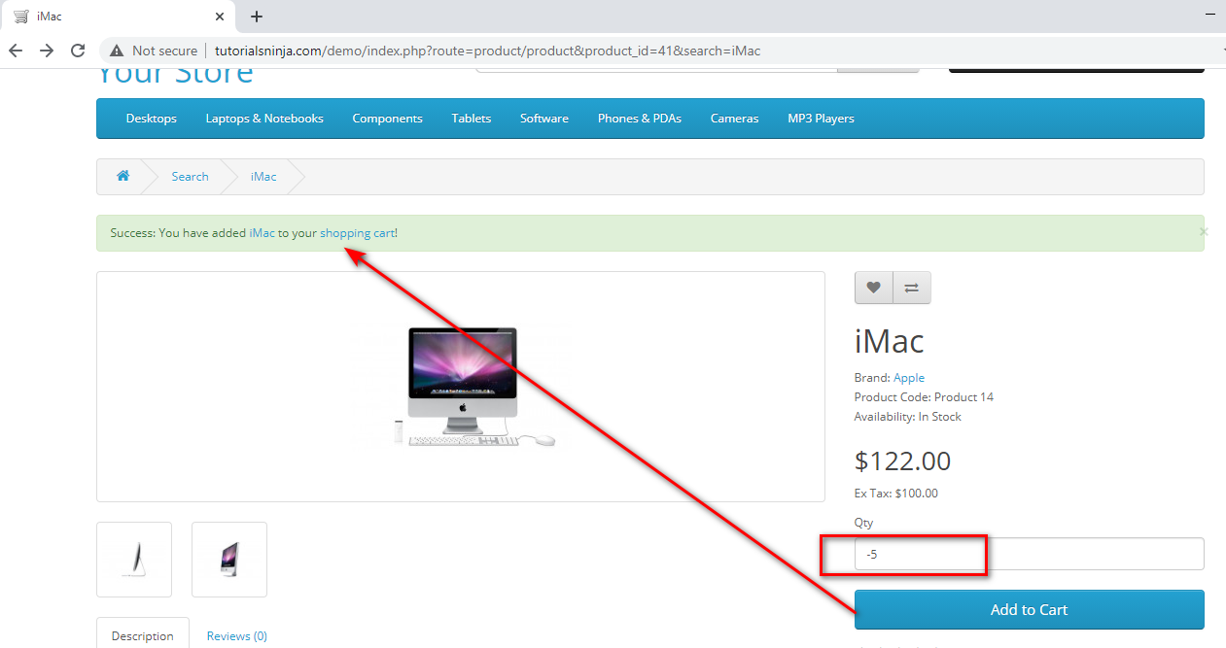
Top
Bug Id | TW1-I15

Brief Summary | Warning message informing the User to provide positive quantity is not getting displayed on updating the quantity with negative, zero or blank in the 'Shopping Cart' page

Severity | Minor

Steps to Reproduce

- Open Application URL
- Enter any Product say 'iMac' in the Search box field
- Click on 'Search' icon button
- Click on 'Add to Cart' button on the product displayed in the Search Results page
- Click on 'Shopping Cart' header option
- Enter -5 into the Quantity field
- Click on 'Update' icon option
Expected Result

Warning message informing the User to provide the positive quantity should be displayed

Actual Result

No warning message is getting displayed, instead 'Your shopping cart is empty!' is getting displayed

Screenshot

Not Applicable
Top

Bug Id | TW1-I16

Brief Summary | $8 is displayed instead of $5 in the displayed 'Estimate Shipping & Taxes' dialog

Severity | Major

Steps to Reproduce

- Open any Application URL
- Navigate to Shopping Cart page after adding a Product to Cart
- Click on 'Estimate Shipping & Taxes' dialog
- Enter Country say 'United States' into the 'Country' text field
- Enter Region/State say 'California' into the 'Region/State' text field
- Click on 'Get Quotes' button
Expected Result

$5 should be displayed in the 'Estimate Shipping & Taxes' dialog

Actual Result

For the first time after opening the browser and following the steps to reproduce, $8 is getting displayed in the 'Estimate Shipping & Taxes' dialog

Screenshot

Not Applicable
Top

Bug Id | TW1-I17

Brief Summary | User can provide future date for the 'Order Date' field while returning the order

Severity | Major

Steps to Reproduce

- Login to the Account having few orders placed
- Click on 'Order History' Right column option
- Click on 'View' icon option of any order displayed in the table of 'Order History' page
- Enter any future date into the 'Order Date' field in the displayed 'Product Returns' page
- Provide/Select all the mandatory fields and click on 'Submit' button
Expected Result

Warning message informing the User to provide a valid date should be displayed

Actual Result

Future Date provided in the 'Order Date' field is accepted and return is placed

Screenshot

Not Applicable
Top

Bug Id | TW1-I18

Brief Summary | Page text is not displayed in the 'About Us', 'Delivery Information', 'Privacy Policy’ and 'Terms & Conditions' page

Severity | Minor

Steps to Reproduce

- Open Application URL
- Click on 'About Us' footer option or other footer options like 'Delivery Information', 'Privacy Policy’ and 'Terms & Conditions' page
Expected Result

Proper page text should be displayed in the pages

Actual Result

No page text is getting displayed in the page as shown in the attached screenshot

Screenshot

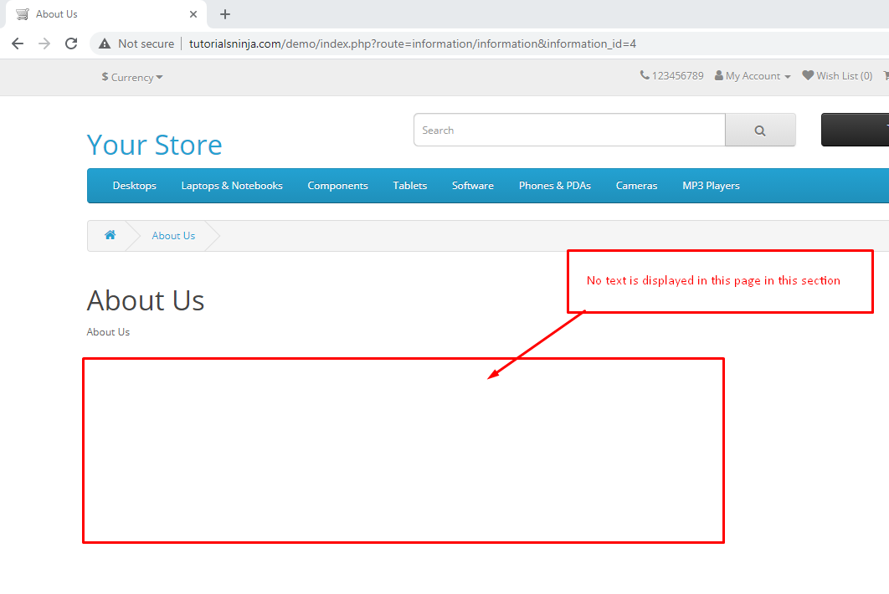
Top
Bug Id | TW1-I19

Brief Summary | Normal User who has not registered for the Affiliate account is able to login from 'Affiliate Login' section

Severity | Major

Steps to Reproduce

- Open Application URL
- Click on 'Affiliate' footer link
- Login from the 'Affiliate Program' page by providing credentials of the normal User who has not registered for an Affiliate account from the 'Affiliate Login' section
- Click on 'Login' button
Expected Result

User doesn't have any affiliate account warning message should be displayed

Actual Result

Normal User not registered for affiliate account is able to login as shown in the attached screenshot

Screenshot

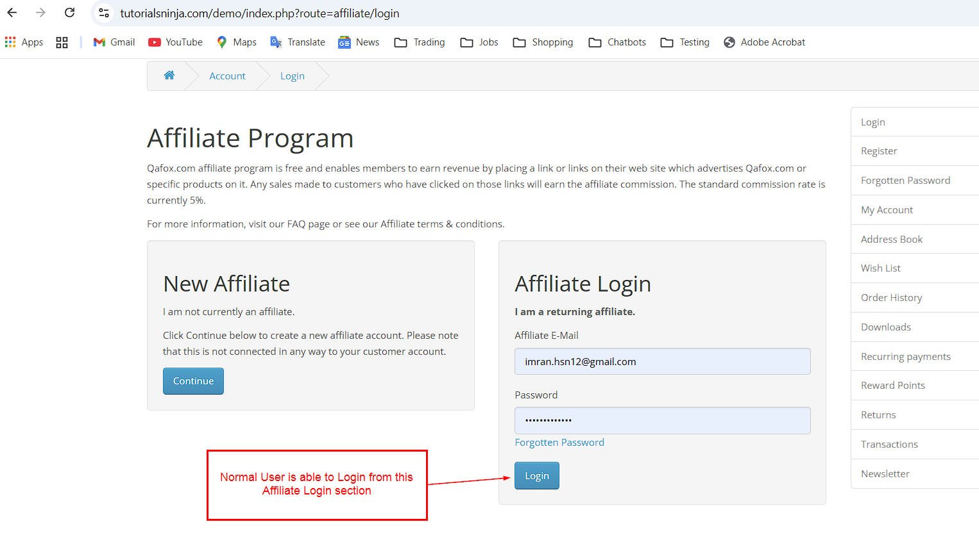
Top
Bug Id | TW1-I20

Brief Summary | Options are not displayed in the 'Select' dropdown list of 'Canon EOS 5D' product display page

Severity | Major

Steps to Reproduce

- Open Application URL
- Enter 'Canon' text into Search text field
- Click on 'Search' icon button
- Click on the Product displayed in the Search results
- Select any option from the 'Select' dropdown field displayed in the Product Display Page
Expected Result

Options should be displayed in the 'Select' dropdown field
Actual Result

Not a single option is displayed in the 'Select' dropdown field as shown in the attached screenshot

Screenshot

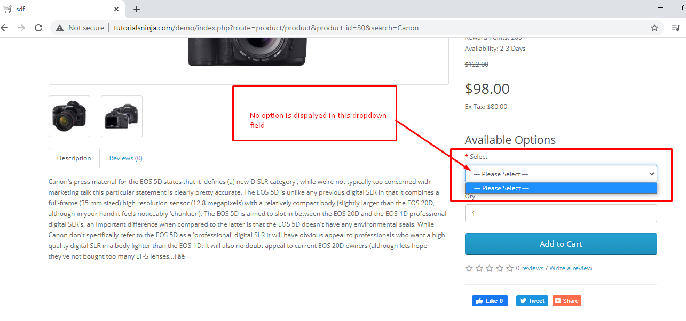
Top

Bug Id | TW1-I21

Brief Summary | Logo of the Application is missing, instead 'Your Text' is getting displayed

Severity | Minor

Steps to Reproduce

- Open Application URL
Expected Result

Logo should be displayed on the top left of the page

Actual Result

Logo is not getting displayed, instead 'Your Text' is displayed on the page as shown in the attached screenshot

Screenshot

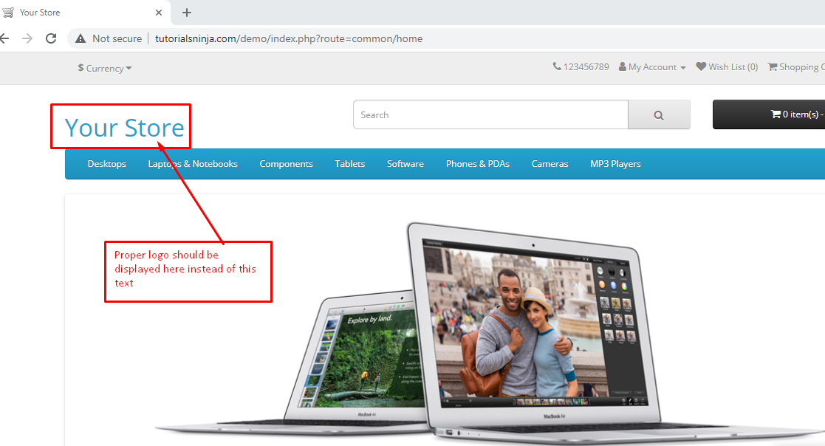
Top

Bug Id | TW1-I22

Brief Summary | Clicking on the first Hero image is taking us to a wrong Product Display Page

Severity | Minor

Steps to Reproduce

- Open Application URL
- Click on the first Hero Image displayed in the Home page
Expected Result

User should be taken to correct Product Display Page

Actual Result

User is taken to a Product Display page of a Tab

Screenshot

Not Applicable
Top

Bug Id | TW1-I23

Brief Summary | A blank 'Contact Us' page is displayed on submitting the form in 'Contact Us' page

Severity | Minor

Steps to Reproduce

- Open Application URL
- Click on 'Contact Us' footer option
- Enter the details into 'Your Name', 'E-Mail Address' and 'Enquiry' fields in the 'Contact Us' page
- Click on 'Submit' button
Expected Result

Success Message with text - 'Your Enquiry has been Submitted!' should be displayed in the 'Contact Us' page

Actual Result

A blank 'Contact Us' page is getting displayed as shown in the attached screenshot

Screenshot

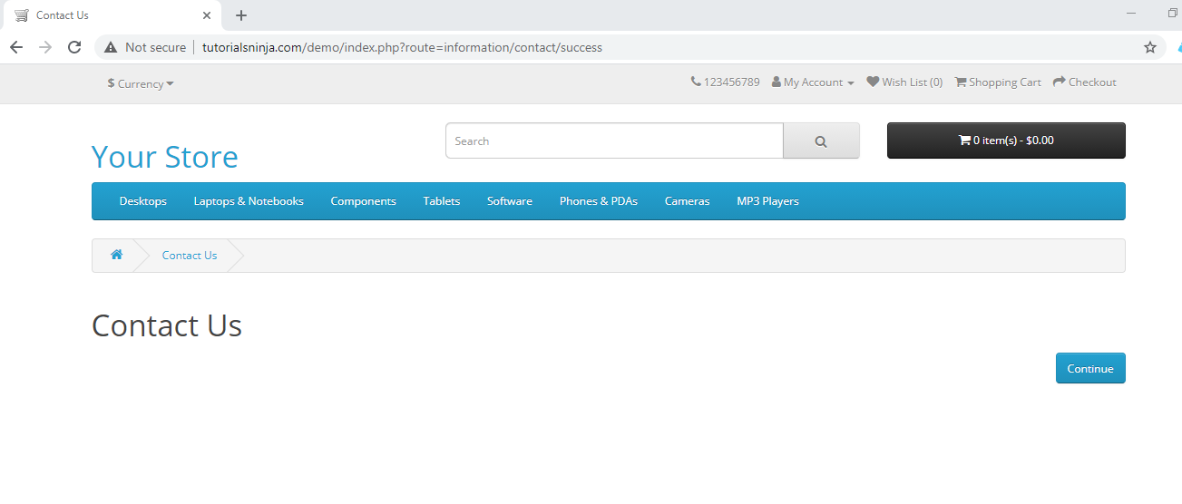Top

